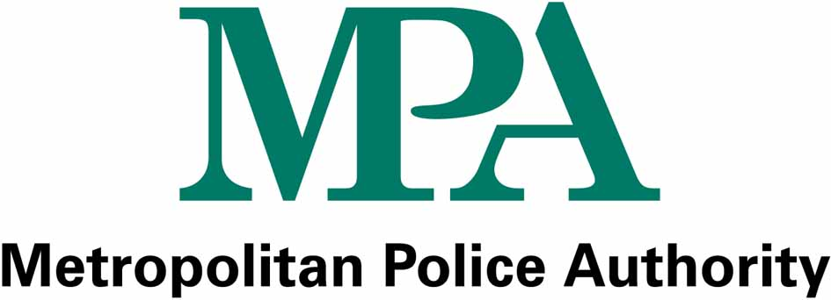

Freedom of Information Act

APPLICATION FORM
Title (e.g. Mr/Mrs/Miss/Ms): Surname:
First Name(s):
Address:

Email address:
Telephone (daytime number and/or mobile if possible):
What information do you want? (please be as specific as possible and continue overleaf if necessary)

If you would like help in making your request please phone us on the number below or tick this box and someone will contact you. | □
We may consult with third parties if the information you have asked for originates from or refers to them. Please tick this box if you would like your name withheld. | □  Please withhold my name
Data Protection Act 1998: your personal data will only be used to enable us to deal your request and for no other purpose. It will not be disclosed to other organisations or third parties without your permission.

Please return this form to:
Liaison Unit,
Metropolitan Police Authority,
10 Dean Farrar Street,
London SW1H 0NY

Fax: 020 7202 0246
Email: enquiries@mpa.gov.uk
Telephone: 020 7202 0185 or 0180

