Service Level Agreement between CPEG and MPA

The MPA funds Community and Police Engagement Groups. In providing resources to the groups, we aim to support and encourage them to develop their activities in a systematic and planned way so that they are able to achieve consistent community and police engagement for the broadest range of community members within the local area.

Each year, subsequent to an initial expression of interest being sent in by the borough CPEG, a completed service level agreement will be provided by that CPEG. On the next page is a copy of the standard service level agreement (SLA) between the MPA and CPEGs.

The SLA provides a simple and clear agreement between the parties about what community engagement services and work will be undertaken in exchange for funding sponsorship. When the SLA is agreed and signed off by both parties, it becomes the basic operational work-plan for the CPEG’s programme of activities for the year.

Each quarter, the lead officer/member of staff of the CPEG will meet with the MPA link officer to monitor to implementation of the SLA and to discuss the developmental issues which may effect the delivery or improvement of services.

These meetings are conducted in a supportive way and seek both to ensure that both parties are doing everything they can to manage and develop the work and functions of the CPEG.

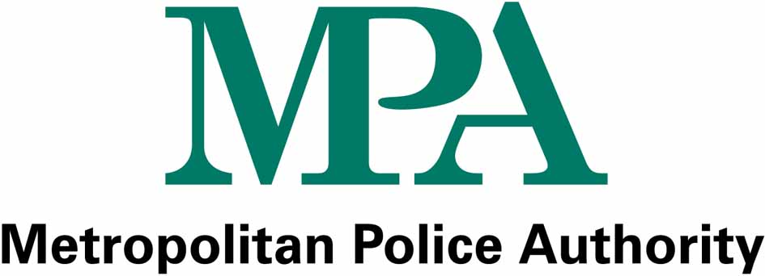
Date of Agreement:

Parties: | - Metropolitan Police Authority, Heron House, 10 Dean Farrar Street, London SW1H 0NY  (“The Authority); and  - [enter full name of grant funded group/organisation]

CPEG Title:
Project costs: | Headline costs  - [enter description and cost £]  - [enter description and cost £]  - [enter description and cost £]  - [enter description and cost £]  - [enter description and cost £]  Total Project Cost £  Total MPA Contribution £
Organisation :
Project Lead: |  | Tel:
Proposed Project Start Date:

Description of the Project: | [enter short description of the project here]

Outcomes (what will have been achieved by the end of the project): | [enter what will be achieved by the end of the project funding period]

Milestones and Key Deliverables:
  Milestone 1 Qtr (Date)
  - [Deliverable 1 - description]
  - [Deliverable 2 - description]
  - [Deliverable n - description]
  Milestone 2 Qtr (Date)
  - [Deliverable 1 - description]
  - [Deliverable 2 - description]
  - [Deliverable n - description]
  Milestone 3 Qtr (Date)
  - [Deliverable 1 - description]
  - [Deliverable 2 - description]
  - [Deliverable n - description]
  Milestone 4 Qtr (Date)
  - [Deliverable 1 - description]
  - [Deliverable 2 - description]
  - [Deliverable n - description]

Amount of Grant Funding: | The amount of Grant Funding that will be made available to the Organisation during the period of this Agreement is £ [enter agreed grant funding] subject to any terms and conditions otherwise described.  Funding will be released in accordance with the conditions described in the  BOROUGH COMMUNITY ENGAGEMENT FUNDING 2008/09 report of 6 March 2008.

Period of Agreement: | PERIOD OF AGREEMENT  Commencement Date: [enter date]  Review Date: [enter date]  Completion Date: [enter date]

The Authority’s and Organisation’s Representatives: | Name:  Title: Head of Engagement and Partnerships  Telephone: 02072020215  email: martin.davis@mpa.gov.uk  - The Organisation’s representative called “the Nominated Officer” throughout the Agreement is [name/title and address]  Name: ……………………………  Title:……………………………..  Address:……………………………………………………………...  Telephone:…………………………  e-mail:……………………………..

The Agreement: | The following documents will constitute the Agreement between the Authority and the Organisation:-  - The Agreement  IN WITNESS this Agreement has been entered into by the parties on the date above written  Signature: …………………………. Signature: …………………………….  Print Name: ………………………. Print Name: ………………………….  Designation: ………………………. Designation: …………………………  Duly Authorised Officer of Duly Authorised Officer of the  The Authority Organisation

