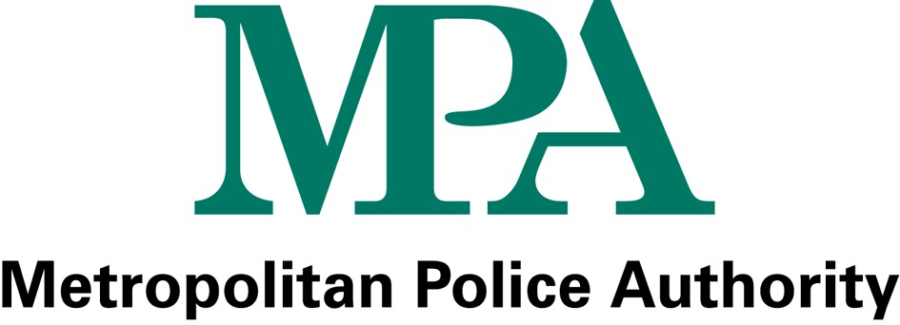

MPA Statement of Accounts summary – questionnaire

Whilst the statement of accounts is a statutory publication and Accounting Codes of Practice and Financial Reporting Standards prescribe much of its content and format, we have more flexibility with the format of the summary accounts. We are therefore keen to ensure that the summary accounts are as user friendly as possible, and would welcome your suggestions on how we can achieve this.

We would appreciate if you could take the time to complete this questionnaire and return it to the following freepost address:

MPA
Freepost LON17808
London SW1H 0NY

The current statement of accounts summary is available from the MPA Website at: www.mpa.gov.uk/reports/accounts/default.htm

1. Is the information provided useful? Yes/No

2. Is the document easy to read? Yes/No

3. Is the information provided easy to understand? Yes/No

If no, what would aid your understanding?
e.g. increased use of charts/graphs, written explanations, non financial information

………………………………………………………………………………………………………………………………………………………………………………………………………………………………………………………………………………

4. Is there any additional information that you would like to see in the Summary Accounts?

………………………………………………………………………………………………………………………………………………………………………………………………………………………………………………………………………………

5. Are there any other ways we could improve the document?

………………………………………………………………………………………………………………………………………………………………………………………………………………………………………………………………………………

